Background
Put yourselves into the shoes of a sponsor’s statistical lead for a novel drug that is at end of phase 2. The drug is developed for treating Episodic Migraine (EM). To simplify things, the focus will be on efficacy, restricted to the primary variable. This primary variable is the number of monthly migraine days (MMD) counted over 4 weeks. The way this is evaluated is typically as follows (example from Phase 2 study):
- Derive change from baseline as (number of migraine days between weeks 9 and 12 of double-blind treatment - number of migraine days during the 4 weeks of baseline). It is assumed normally distributed.
- Analyze difference in means using ANCOVA
At the end of phase 2 dose-finding study with 4 arms (3:2:2:2 randomized, Placebo vs 3 doses of active, Dose_1, Dose_2, Dose_3), the following information for “Monthly Migraine Days” (MMD) are available and summarized below.
 | Treatment Group
 | Placebo | Dose_1 | Dose_2 | Dose_3
Change from Baseline
N | 153 | 108 | 105 | 105
Mean MMD (SE) | -2.2 (0.4) | -2.1 (0.4) | -2.4 (0.5) | -3.3 (0.4)
**Adjusted Analysis
LSM estimates | -2.3 (0.3) | -2.2 (0.4) | -2.4 (0.4) | -3.4 (0.4)
95% CI of LSM | (-2.9, -1.7) | (-2.9, -1.5) | (-3.1, -1.6) | (-4.1, -2.7)
Difference in LSM |  | 0.1 | -0.1 | -1.1
95% CI of difference |  | (-0.8, 1.1) | (-1.1, 0.9) | (-2.1, -0.2)
p-value |  | 0.8 | 0.8 | 0.021
**The adjusted analysis taken from the sponsor’s materials is essentially the same as the unadjusted analysis. The adjusted analysis utilizes a generalized linear mixed model which includes treatment, visit, treatment by visit interaction stratification factors, and baseline values as covariates.

Following this Phase 2 study a decision has been made to conduct two phase 3 studies of Dose 3 versus placebo randomized in a 1:1 ratio, described as Study A and Study B.
During a Type B meeting, the sponsor received encouraging feedback on the quality and usefulness of the phase 2 study (see below). While we lack details around why this question was being asked and whether there had been any previous discussion with the agency around that topic, we interpret the statement in the following way:
- The phase 2 study is seen as a high-quality study which generated reliable evidence.
- The study provides both, useful information on the treatment effect, but also on the effect in the control group.
- We will focus on using the information from the control group.
FDA DISCUSSION
Question 1 – Phase 3 Studies
Does the Agency agree that the proposed global, randomized, double-blind, placebo controlled, pivotal, phase 3 studies (Studies A and B) are sufficient to support product registration for prophylaxis of episodic migraine headache in adults?
FDA Response:
On face, the proposed phase 3 studies (Studies A and B) appear adequate to support product registration for prophylaxis of episodic migraine headache in adults. However, we note that your completed study in episodic migraineurs (Phase 2 Study) has many of the characteristics of an adequate and well-controlled pivotal efficacy trial. We are open to an argument that the results of that study could also support a marketing application for your product.

You will now work through a scenario building on this encouraging feedback by exploring how data from a completed Phase 2 study can be incorporated into an analysis of Study B as a historical control.
Phase 3 Design (Study B)
The primary objective of this trial is to evaluate change from baseline in mean MMD in subjects with EM. This is a phase 3, multicenter, randomized, double-blind, placebo-controlled, parallel group study of subjects with EM. Eligible subjects identified in the screening phase commence a 4-week baseline phase after which eligible subjects are randomized in a 1:1 ratio to receive placebo or NEWTRT DOSE_3 for the duration of the 12-week double-blind treatment phase. Randomization is stratified by region (North America or ‘Other’) and treatment status with migraine prophylactic medication (prior only, current, or neither prior nor current).

Eligible subjects are adults 18 to 65 years of age with history of migraine with or without aura for ≥ 12 months who experienced >= 4 to < 15 migraine days per month with < 15 headache days per month, on average across the 3 months prior to screening

The primary endpoint for this study is the change in MMD from baseline to the last month of the 12-week double-blind treatment phase. Approximately 540 eligible subjects (270/arm) are required for the study to achieve 90% power (1-sided alpha = 0.025).

While feasibility should not be an issue when conducting studies in episodic migraine, given this is a placebo-controlled study and high-quality historical data is available, it appears attractive to move away from 1:1 randomization by utilizing the historical data.

Proposed Development Program
The Sponsor proposes that the package to support regulatory submission will include two pivotal trials. The first is Study A (which will not be enriched with historical control data) and the second is a Study B including control group data from the Phase 2 study.

Revised study proposal (breakout session)
- The assumptions underlying the originally planned study B are provided below. Briefly confirm within your team that this is an adequately planned pivotal study.
- Standard deviation (for change from baseline, within-arm): 3.78 (based on ph 2 data)
- True treatment effect (alternative) to power the study: -1.12 (based on ph 2 data)
- Power: 90%
- 2-sided α=0.05
- 10% drop-out rate assumed

sigma_ref <- 3.78
pwr.Ph3B <- power.t.test(n = NULL, delta = -1.12, sd = sigma_ref, sig.level = 0.05, power = 0.9, alternative = "two.sided")
n.per.group.fas <- ceiling(pwr.Ph3B$n)
n.per.group.calc <- ceiling(n.per.group.fas/0.9)
pwr.Ph3B
##
## Two-sample t test power calculation
##
## n = 240.3367
## delta = 1.12
## sd = 3.78
## sig.level = 0.05
## power = 0.9
## alternative = two.sided
##
## NOTE: n is number in *each* group
n.per.group.fas
## [1] 241
n.per.group.calc
## [1] 268
# as per FDA docs
n.per.group <- 270

- You now build a robust mixture prior for the control group. This robust mixture prior consists of two components:
  - Component 1: the posterior based on the phase 2 data
  - Component 2 : A vague (unit-information) prior
For explanation, the posterior based on the phase 2 data is derived using a flat (improper) prior, i.e., it is a normal distribution with mean and standard deviation corresponding to the ones obtained from a stand-alone analysis of the phase 2 study.
The unit-information prior is a normal distribution with standard deviation equal to “one unit of observation”, corresponding to 3.78 (which is the standard deviation for the change from baseline).
The mixture weights for the two components are 80% and 20%, respectively. While the choice of the weights would require detailed justifications in practice, here we assume the above choice being adequate. Prior summaries are given in the table below and in visual form (densities).

Table: prior for placebo mean change from baseline in MMD

 | Mean | SD | Median | 2.5% | 97.5%
Informative | -2.3 | 0.30 | -2.3 | -2.90 | -1.71
Vague | -2.3 | 3.78 | -2.3 | -9.81 | 5.11
Robust | -2.3 | 1.71 | -2.3 | -6.65 | 2.05

Figure: prior for placebo mean change from baseline in MDD
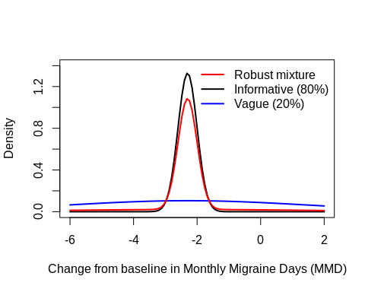
Revised study: the robust prior has a prior effective sample size (as assessed by ELIR) of approximately N = 110. While additional considerations (such as studying power varying the control group size) are required in practice, in this case study we will reduce the control arm by ~1/3 (80 patients), i.e. use 3:2 randomization for Study B. The decision criterion for statistical study success requires at least 97.5% posterior probability that NEWTRT is better than placebo.
In the following figure, we use a sample size of “evaluable” patients, meaning 10% of the randomized patients drop out. This makes comparisons simpler since the evaluable number of patients yields 90% power for the frequentist design.

A comprehensive summary of the operating characteristics is given in the figure below. Note that comparisons are made versus the original frequentist design (N = 240 evaluable patients for NEWTRT and placebo, respectively). “Type I error” is 1-sided.

Figure: operating characteristics for the original and the Bayesian Dynamic Borrowing (BDB) design
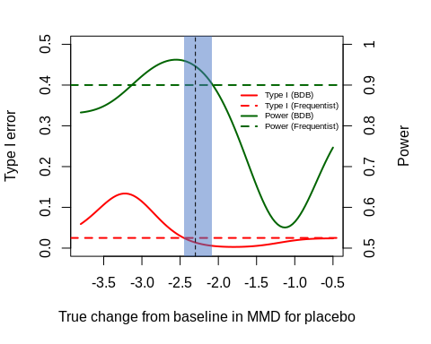

Points to consider for discussions with regulatory authorities
In your breakout groups, please consider the following questions:
- Considering the information above, discuss in your team what pros / cons you see with the proposed approach. Do you feel comfortable with the proposal and agree to approach regulators?

- What would you include in a Company position to support the use of the Phase 2 data as a historical control in the analysis of Study B?

- Are there any other Tables or Figures you would provide to support the use of HC data in the analysis of Study B?

- What other information would you provide to support the use of HC data as part of a pivotal Phase 3 program?

- What other questions would you ask a regulatory agency when using HC data as part of a regulatory approval?

- What if now there was just Study B in the confirmatory package – what implication would that have? Would it change your position?

- Now imagine you were on the regulatory side, what (other) questions would you ask?

Additional points for discussion
Would any of the following features affect the discussion you would be likely to have with the regulatory agencies?

- Proposal to borrow from historical data on treatment effect rather than borrowing on the control group rate
- Differences in IN/EX criteria, covariate distribution, timeliness of historical data
- Historical data available from external trial or literature rather than Sponsor Ph2 study
- Availability of multiple historical data sources instead of a single one
- Availability of observational data / RWD rather than randomized clinical trial data
- Availability of HC data at the design stage (i.e., awareness of HC results) versus HC data generated in parallel to pivotal trial
- Other borrowing approaches
- Adjustment for prognostic factors
- Borrowing for a pivotal phase III trial in adults vs. pediatric phase III vs. rare disease phase III setting vs. borrowing for a non-pivotal trial

Additional material

Study A
The primary objective of this trial is to evaluate the effect of NEWTRT compared to placebo on the change from baseline in mean monthly migraine days in subjects with EM. This is a phase 3, multicenter, randomized, double-blind, placebo-controlled, parallel group study of subjects with EM. Eligible subjects identified in the screening phase commence a 4-week baseline phase. After the baseline period, eligible subjects are randomized in a 1:1 ratio to receive placebo or NEWTRT Dose_3 for the duration of the 24-week double-blind treatment phase. Randomization is stratified by region (North America or ‘Other’) and treatment status with migraine prophylactic medication (prior only, current, or neither prior nor current).

Eligible subjects are adults 18 to 65 years of age with history of migraine with or without aura for ≥ 12 months who experienced >= 4 to < 15 migraine days per month with < 15 headache days per month. Approximately 852 eligible subjects are planned to be randomized, in a 1:1 ratio to the treatment groups

The primary endpoint for this study is change in MMD from baseline to the last 3 months of the 24-week double-blind treatment phase.

