PSI Special Interest Group: Application and Implementation of Methodologies in Statistics (AIMS)
The AIMS SIG wants to promote different technologies that are available to us across multiple industries helping us shape, explore, analyse and present our statistical thinking to different audiences. In this regard we will be publishing a series of articles available in SPIN and online in our area on the PSI website about various tools. We will talk about RStudio in this article.
In the interest of transparency, here is a list (taken from Wikipedia) of other graphical user interfaces (GUIs) and integrated development environments (IDEs) you can use with R:
- Architect – cross-platform open source IDE for data science based on Eclipse and StatET
- Deducer – GUI for menu-driven data analysis (similar to SPSS/JMP/Minitab)
- Java GUI for R – cross-platform stand-alone R terminal and editor based on Java (also known as JGR)
- Number Analytics – GUI for R based business analytics (similar to SPSS) working on the cloud
- Rattle GUI – cross-platform GUI based on RGtk2 and specifically designed for data mining
- R Commander – cross-platform menu-driven GUI based on tcltk (several plug-ins to Rcmdr are also available)
- Revolution R Productivity Environment (RPE) – Revolution Analytics-provided Visual Studio-based IDE, and has plans for web based point and click interface
- RGUI – comes with the pre-compiled version of R for Microsoft Windows
- RKWard – extensible GUI and IDE for R
- RStudio – cross-platform open source IDE (which can also be run on a remote Linux server)
- Programming editors (Emacs, Eclipse, Notepad++ among others)
This list is not exhaustive; there are many other alternatives out there and if you wish to share your experiences with the AIMS team please feel free to write to ctoffis@amgen.com!
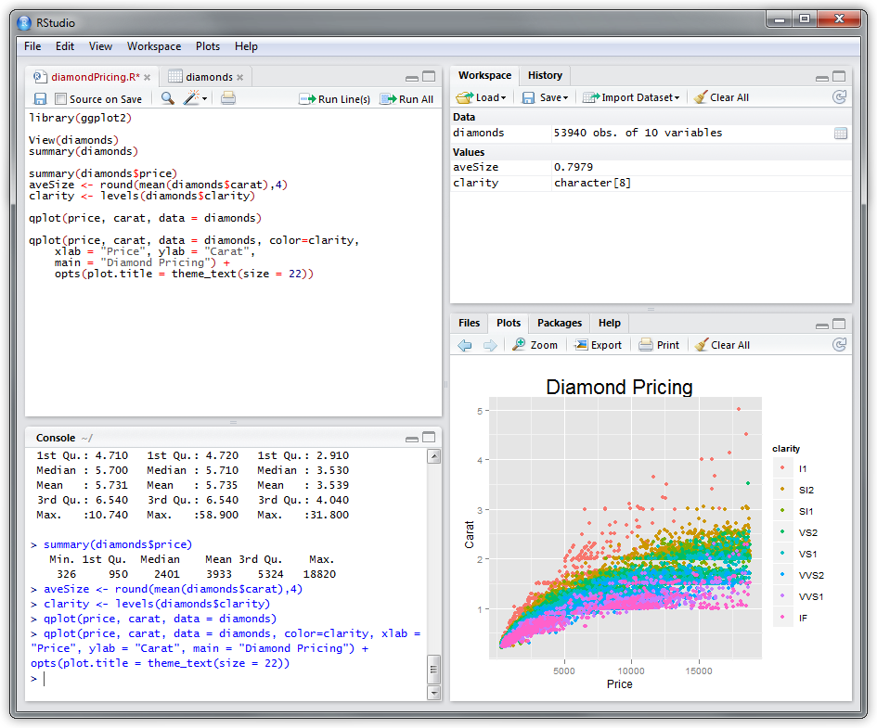
RStudio running in Windows
Most of us in the pharmaceutical industry have probably come across R either through our university studies, in a training course/academia or through work as part of exploratory analysis. R is a command-line interpreter which means users can enter commands (e.g. 1 + 1) and obtain results instantly. By itself, it offers the user access to a very powerful piece of software to manipulate data and produce a summarised analysis with only a few lines of code. However, some drawbacks of this type interface are the unobvious access to some of the elements that makes R so powerful. Being able to see what data you have currently created, what help can you get on a particular package in a neat interface or perhaps the ability to create a script that can do a specific task without having to open a separate window – all of these are possible using R but in a not necessarily friendly manner.
RStudio, among many others, is a powerful front-end for making full use of R. Opening RStudio you are presented with 4 panels, we have:
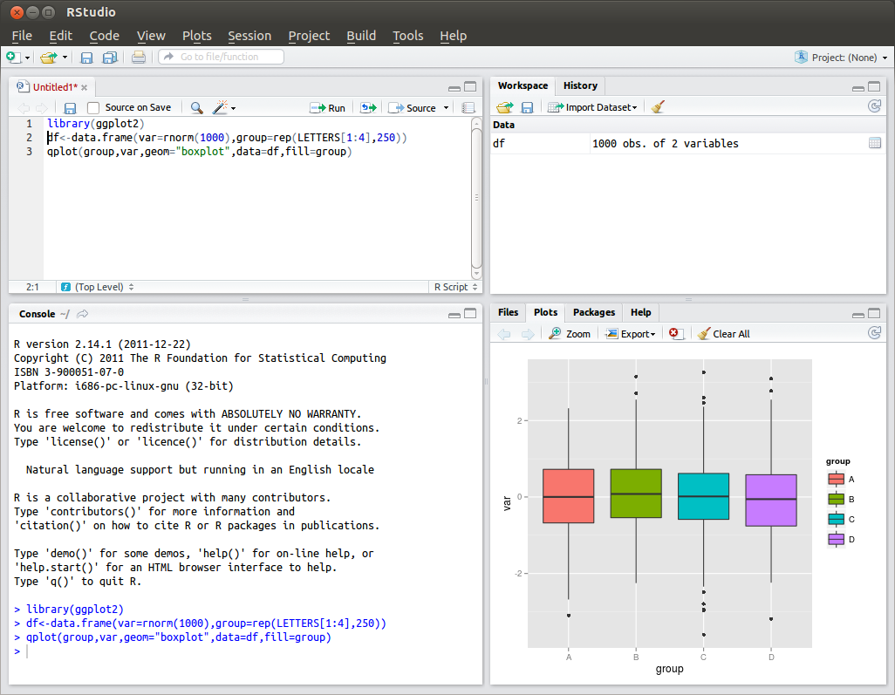
RStudio running in Ubuntu
- Bottom Left, The Console:
This is essentially where R is run from. The command line (in blue) at the bottom are where commands can be entered.
- Top Left, The Code Editor:
We can write code here and submit some or all of it to the Console to be run. This panel can also display tabulated data such as matrices or data frames.
- Top Right, The Workspace:
Contains all the variables and functions created in the session as well as an ongoing history of the commands submitted to the Console.
- Bottom Right, The Multi-Tool:
Provides a means to read/view file directories, display plots from analyses, search ‘on-the-fly’ in the help manual and view what packages are available to use as well as installing new ones.
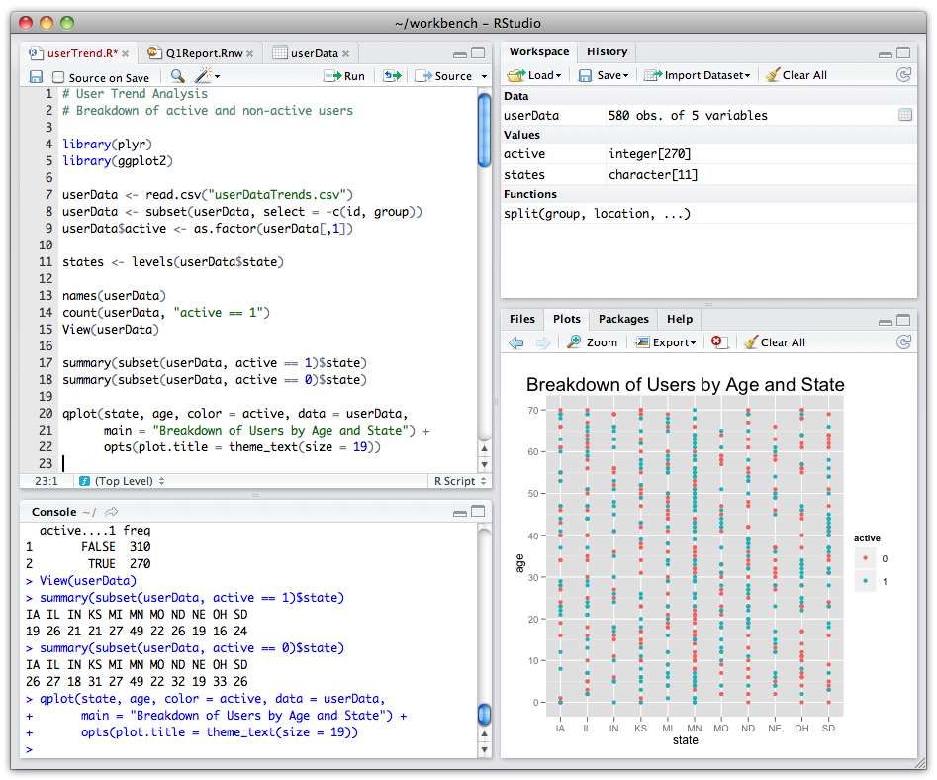
RStudio running on Mac
Using an IDE we now have the power of R with the added functionality to access all the things we may need to conduct an analysis. Want to write a short script to without entering each line into the console? Use the code editor. Can’t remember what information is in that data frame you just created? Take a look at the Workspace. Can’t remember what a particular function’s arguments should be? Search for it under the help tab.
RStudio builds on the fantastic analytical tools available to you with R and brings everything else you might need front and centre.
It should be noted that RStudio needs R to be installed in order to work – some products (such as RGUI come with a pre-compiled version to use).
Chris Toffis (Amgen),
On behalf of PSI AIMS SIG

