Attendees:
Team Member | Present at meeting
Craig Mcilloney (PPD) | √
Lyn Taylor (PRA) | √
Chris Toffis (Amgen) | √
David Inman (GSK) | √
Wilmar Igl (AZ) | √
Yann Robert (Servier) | √
Ed Gash (Mango solutions, Senior account manager) | √
Andy Nicolls (Mango solutions, head of consultancy) | √

Presentation by Mango Solutions
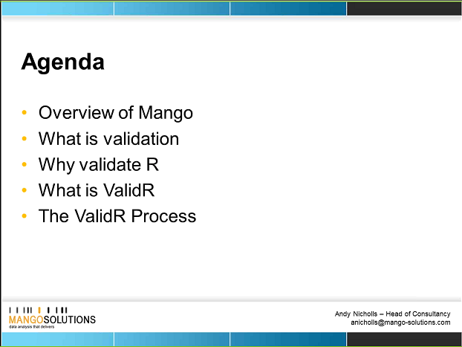
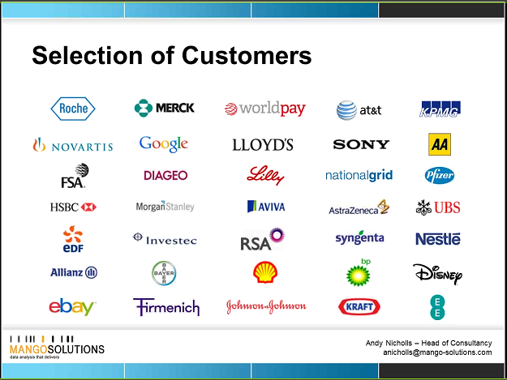
What is validation?
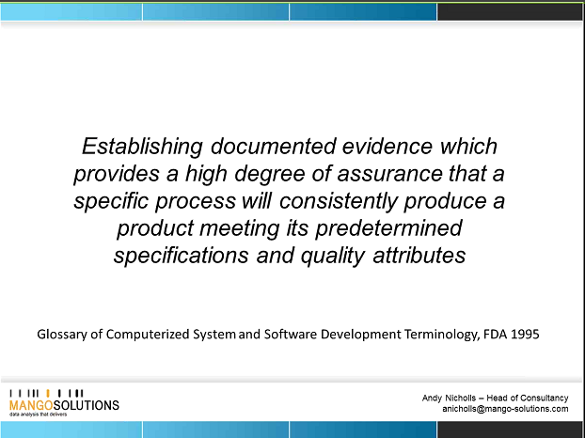
R: Why do we need to validate?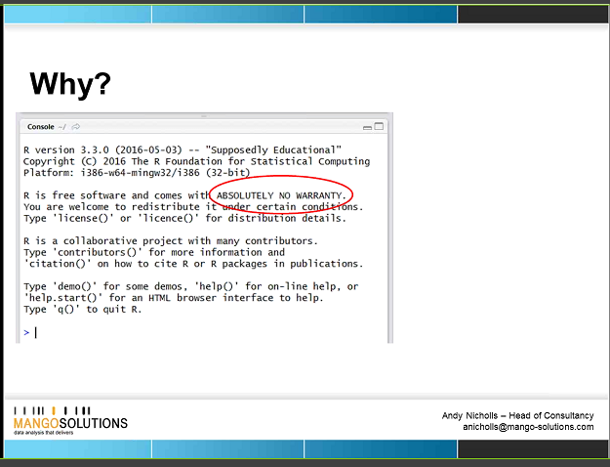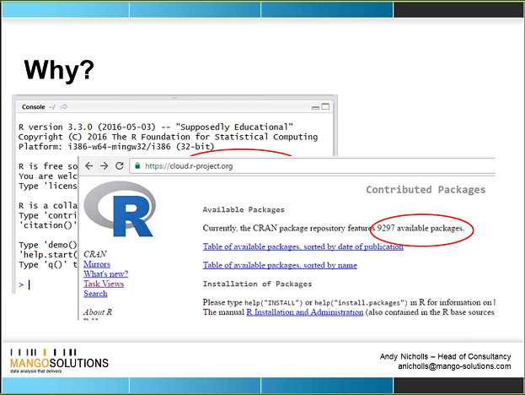
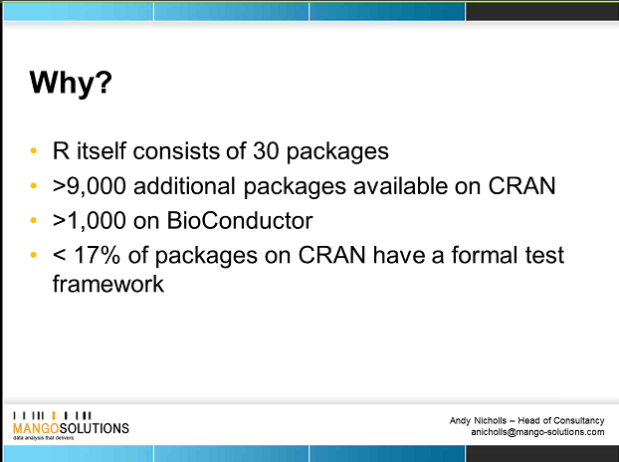
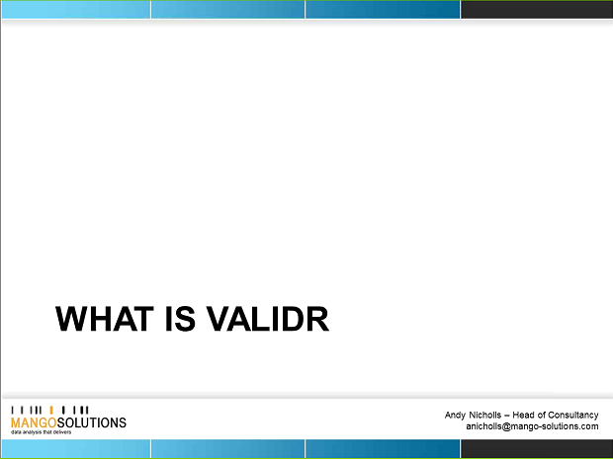
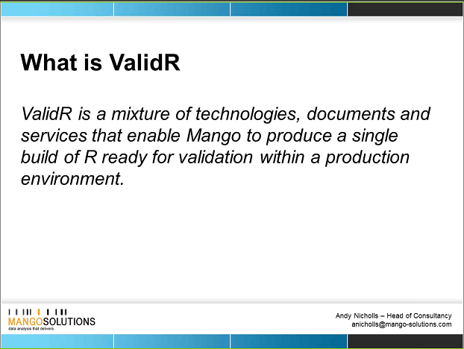
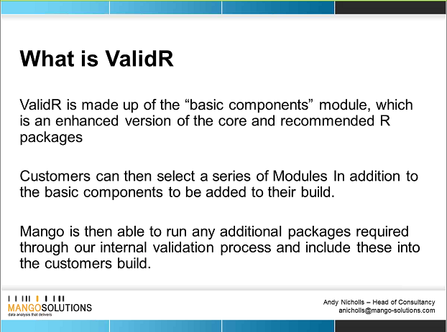
ValidR: includes 30 packages + as default 15/16 extras which are ones people will download anyway. This is the set of packages that mango have validated.
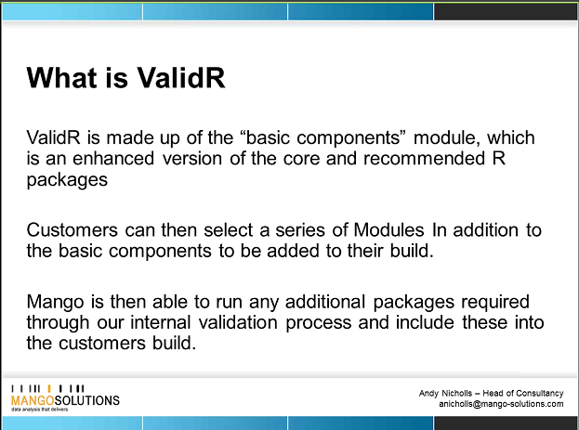
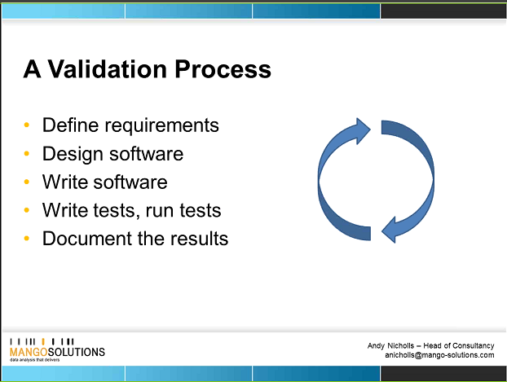
One problem with validating R, is that you aren’t the ones defining the requirements at the start, others wrote the code for their requirements.
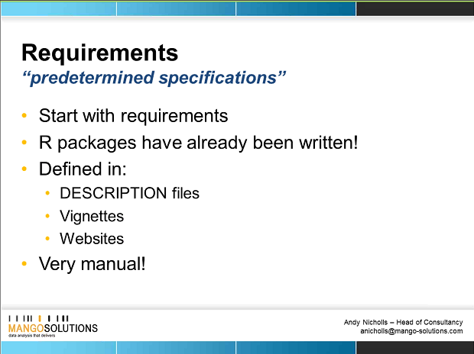
Risk assessment: You can define Low/medium or high risk package based on CRANs metrics.
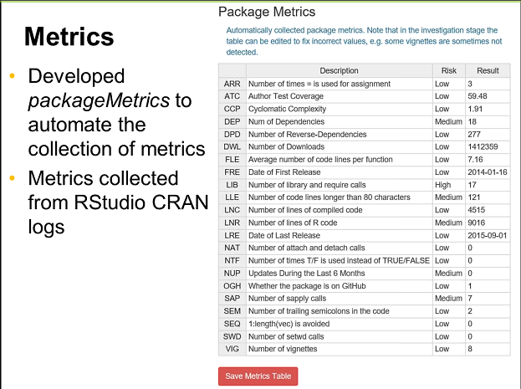

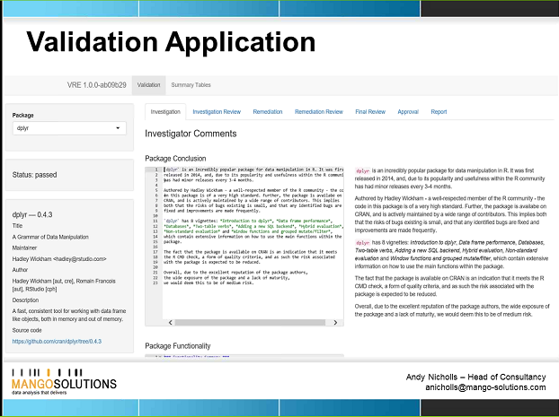
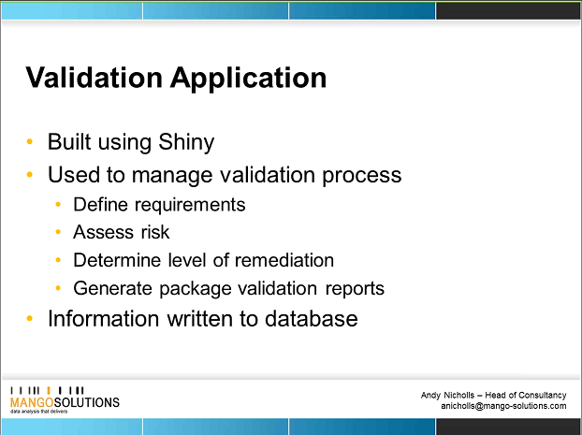
Creates reports of the validation, documents validation status after tests are run.
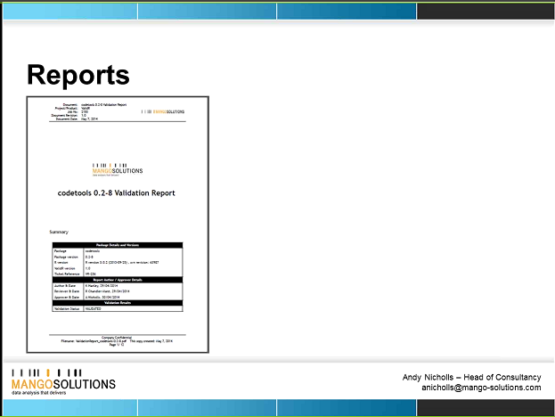
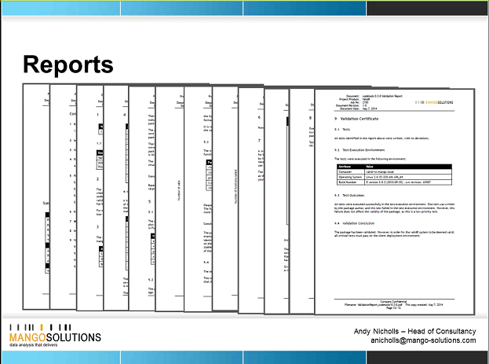
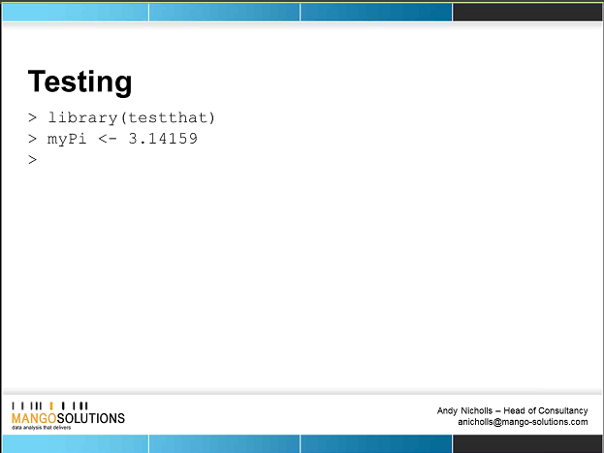
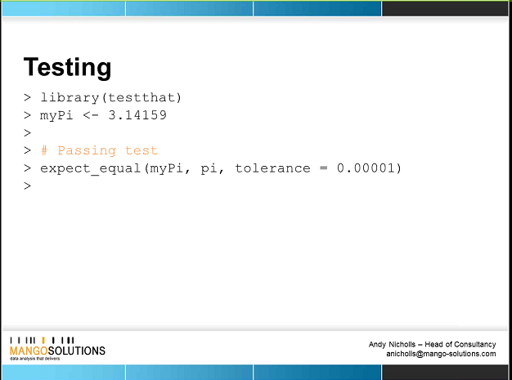
Svunit, runit – are other functions that can do testing…. But testthat is the standard used in r.
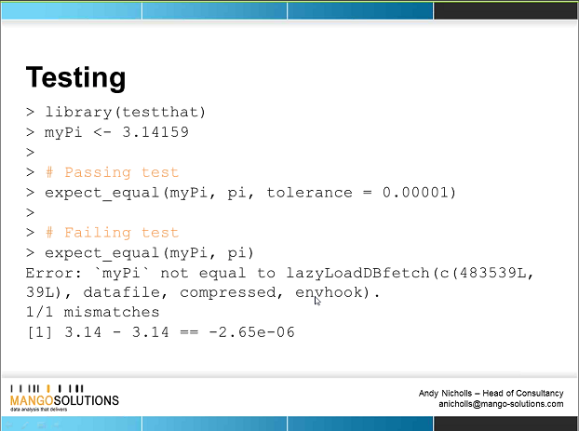
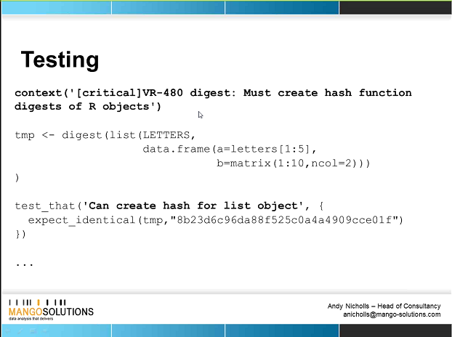
Prioritize requirements into high, medium & low. (Digest is another package that can be used).
When you install R, all tests much pass a critical level.
RPM = is like an exe (executable file) but for linux. It’s a double clickable installation piece (installer) for linux. For each intall you get: Installation qualification, performance qualification (checks being done consistently & in an allowable timeframe) and OQ=Core bit, makes sure every test is passing.
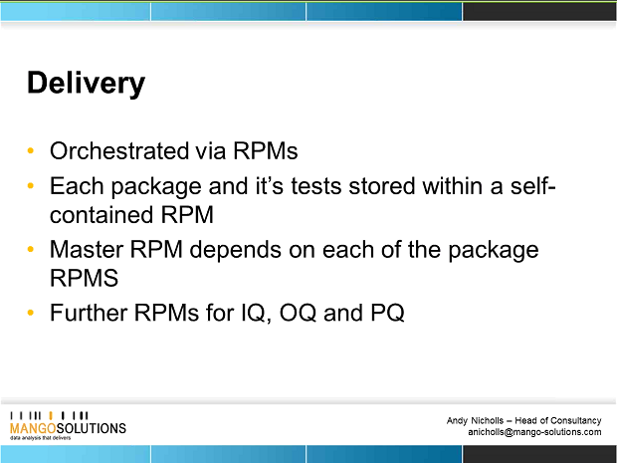
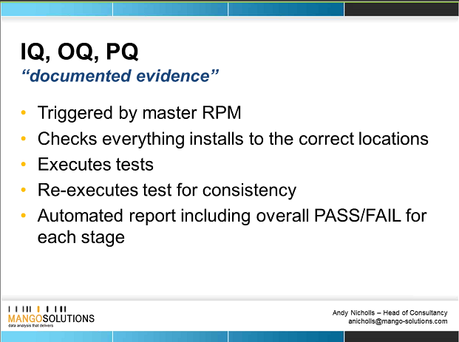
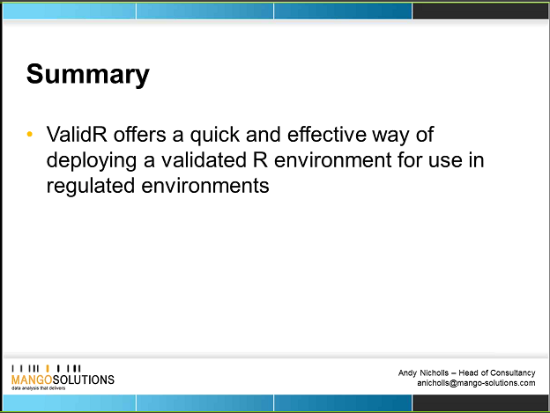

Craig questions:
- How are regulators viewing this? Answer: Mango have had customers audited by regulators, and it has met the needs of audit. Not had any complaints .
- Have any of mango’s customers actually used R in submissions? Or was it used for internal use only.? Answer: Yes, from pharmacometrics perspective, but not used R to do primary statistical analysis or ADaM data.
- Where we want to go is to give the PSI membership guidance of when & when not to use R and perhaps when Mango can help them. Answer: Mango hope one day a client will use their package ValidR to do a submission. But no-one has used R in any form yet for full submission. At the moment it’s more helping customers to use R in a sas supporting software – simulations, Graphs, etc. Mango do not have an end-to-end submission option. R used for extra use cases only. There is a SAS export package in R, which allows creation of SAS transport files in R usable in a submission. So far it’s only being tried in small places & people are not trying to replace SAS.
- What our group want to do is to look at all the options and be able to tell our members when we recommend using Mango and when it doesn’t do what we want. Answer: SAS is there for the long hall, it’s not going anywhere, but it is useful to share with PSI members where R can be used to speed up analyses, or do something sas can’t.
Chris questions:
- Seems like R is subject to more scrutiny than SAS. Answer: it’s due to how software is classified, SAS is off the shelf software, so although SAS has to be validated on installation, it’s not validated in same detail as R, because the developers themselves (1 product/ single vendor) & FDA can audit SAS and check they are happy about the way SAS create the end product. With R, we have the core product & foundation responsible for the 30 packages but the other packages have no control, written by individuals with unregulated validation.
Wilmar
- Is it documented somewhere how SAS is validated? Answer: They will have had to show they are compliant with 21 CRF, the way mango validate R is a standard approach (Gamp 5- GXP validation, good automated manufacturing practice). This is a certain level of detail to go into when testing/validating. Expect SAS are following similar principals but based on their pre specified requirements written at start. ACTION: Ed, to send GAMP 5 example
- Is it a specific problem because R has frequent updates, how does VALID R cope? Answer: valid R is fixed on a version of R, cycle for updates about every 3 months, X.X.A - A updated every 3 months. Mango is fixed on the highest minor version which means Mango has new release of validR about once a year. For example, if we are on 3.2.5 and 3.3.0 gets released then Mango will release validR for 3.2.5. They then validated next highest 3.3.A level when 3.4.0 comes out. It is recommended to take a fix of the CRAN library & only allow use of those packages at that time, so can be validated & no more updates. This does reduce flexibility of R, but ensures it’s a fixed version. If a package comes out yesterday, then you can’t be confident it’s OK… so Mango packages would have a minimum amount of time it’s been released for before it would go into ValidR.
- ValidR has a set of core packages which are validated… but what about the large number which aren’t validated. PSI AIMS would like to give some recommendations about how PSI members can validate packages themselves (obviously validation wouldn’t be as good as Mango would do), but at least it would be some validation? Answer: 30 validated as core R, but validR has about another 150 packages which are validated. (key packages such as GGPLOT2, DPRIOR, RESHAPE2). ValidR also has modules which can be Add ons, to do analyses which may be needed for specific tasks and which are recommended to use. I.e. if 5 packages do similar things, they can give guidance of which of the 5 is the better one to use, i.e. perhaps by a more renowned author – Mango can share best practice and suggest not using the other 4 packages & use only the 1 which is written better and these they select for valid R. If a package is released frequently, then it could suggest it’s well maintained, those hardly ever updated could be redundant, incorrect or out of date. However, some hardly ever updated packages could indicate they are stable & don’t need updates – so need a experience in the packages to know which type they are and how reliable. Can try to use the auto metrics (number of downloads) to guide but need also knowledge of who the author is, i.e., Hadley Wickham (Chief Scientist at RStudio) renowned author and written many packages.
- If mango find a bug, do they feed back to the authors what they find? Answer: Yes, the feedback, they have identified 6/7 major issues in the packages they’ve review to date, sometimes in older version of package & already updated in newer version. Mango also suggest fixes for the packages too. If find issue they have to decide whether to release in Valid R with known issue or update to a newer version (but that can have problems too)
Mango suggest us looking at:
- Good practice package: gives a score for packages: Available to download to give guidance .
- COVR – gives a score of what % of code is covered by tests.
- Structure & coding standards (naming conventions, indentation)
Craig:
- What is the situation contractually. What do a PSI member need to do to use one of mango’s tools. Answer: main deployment option is server based, but looking into number of user options and in future amazon download options. ACTION: Ed: to send list of options for who to get the software.

Valid R, been available since 2009.

Action Items

Action Item | Assigned team member(s) | Deadline | Status
Write SPIN R introduction for industry statisticians (not a technical stance but more Why is learning R a worthwhile effort)  Chris to start by providing some text in this area & share with group | Chris | 24 Dec 2016 | Open
Rstudio Introduction for industry statisticians. Wilmar to make a start in this area and share with group | Wilmar | Approx: January 2017 | Open
MHRA/EMEA their current usage & how they see things going in future, what do they look for from us to satisfy them that the package used (R package used for the submission) is validated. Craig to ask Anna. | Craig | December 2016 | Open
If possible, find out how Mango solutions have been used at GSK | David | December 2016 | Open
Send any questions for Mango solutions to Lyn who will consolidate & send to Ed | All | 28th nov 2016 | Open
Can Ed send evidence of what Gamp 5- GXP validation, good automated manufacturing practice is? | Ed | 5th December 2016 | Open
Ed: to send list of options for how to get the ValidR software and what options are available for purchase. | Ed | 5th December 2016 | Open

